**Requesting a Password Reset Code to Update Your Password on the Eligible Training Provider List**

If you have confirmed your email address with the Maine JobLink, you can use this procedure to reset an expired password.

1.Enter your username

2.Do not enter anything in the password field. Instead, choose Forgot Password.

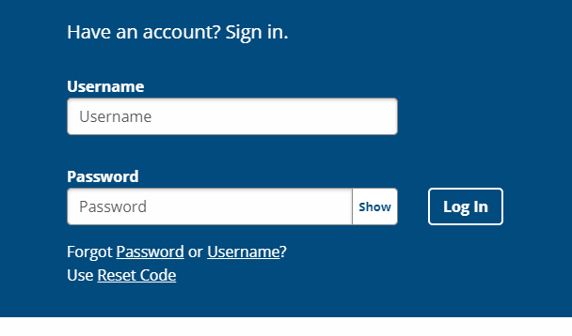

3. Then you will see this screen. Enter your username again and select Submit.

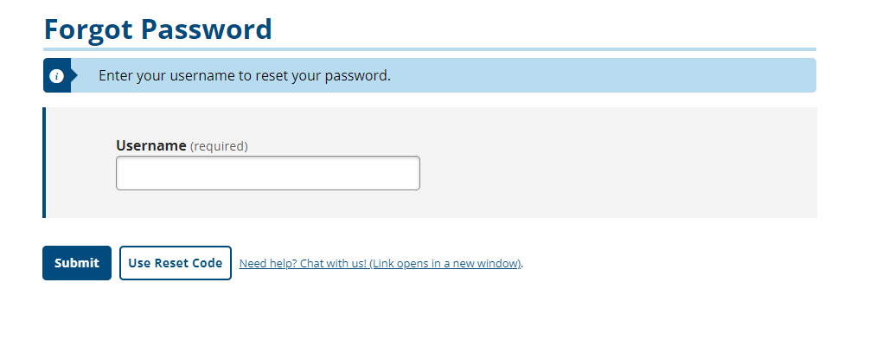

Continued on next page

4. Next, you will see this screen. Your email is confirmed in our system, so select Email and you will receive an email with the reset code.

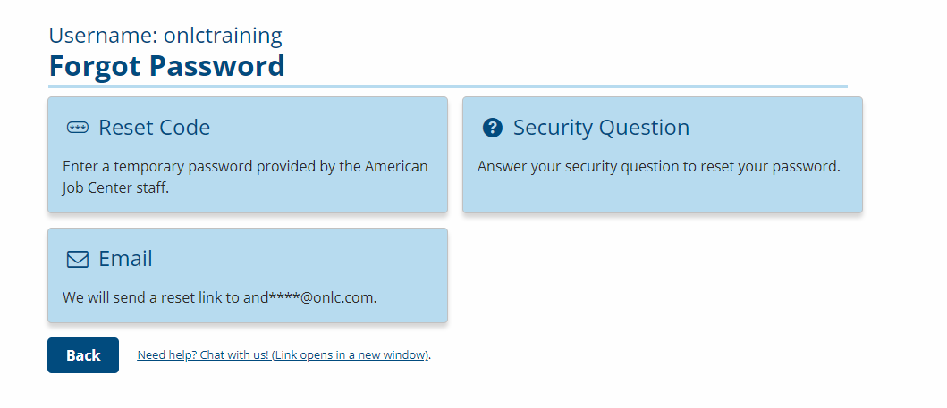

5. Now using the reset code you received, go back to the original log in screen, enter your username and select Use Reset Code. From there, you can follow the prompts and reset your password.



6. **Remember to log in every 2 months to keep your account and password active**. If your password expires, you can use this procedure to reset it.

If your user account is disabled, you will have to contact [ETPLInfo.DOL@maine.gov](mailto:ETPLInfo.DOL@maine.gov)